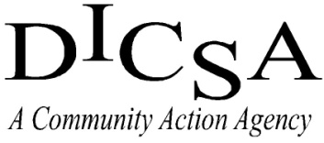
(MSSA) Michigan Student Service Award
Program Application

Name:_________________________________________________________ Birth Date: _______________________

Address:___________________________________________________________________________________________

Phone:________________________________________ Email:_____________________________________________

School:________________________________________ Grade:________ Expected Year of Graduation:___________

_____________________________________________________ _______________________
Student Signature Date

Parent/Guardian Permission:

_______________________________ has my permission to consider and/or accept volunteer opportunities referred to him/her by the high school or MSSA Coordinator. I consent to the use of his/her name and/or photograph in any media.

____________________________________________________ _______________________
Parent/Guardian Signature Date

Complete and Return To:

Your school guidance counselor

-OR -

Dickinson Iron Community Services Agency
Attn: MSSA Coordinator
1238 Carpenter Ave.
Iron Mountain, MI 49801

Phone: 906-774-2256
Fax: 906-774-2257

